**Deploying Database to Azure**

On the Home page click on Database

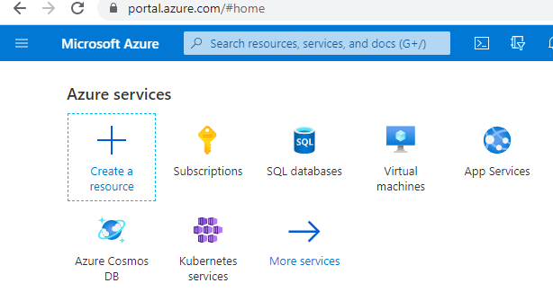

Click on Add

Edit field as seen below.

On The right hand panel fill in Server Name admin login and passwords.

Once done click on Review and Create.

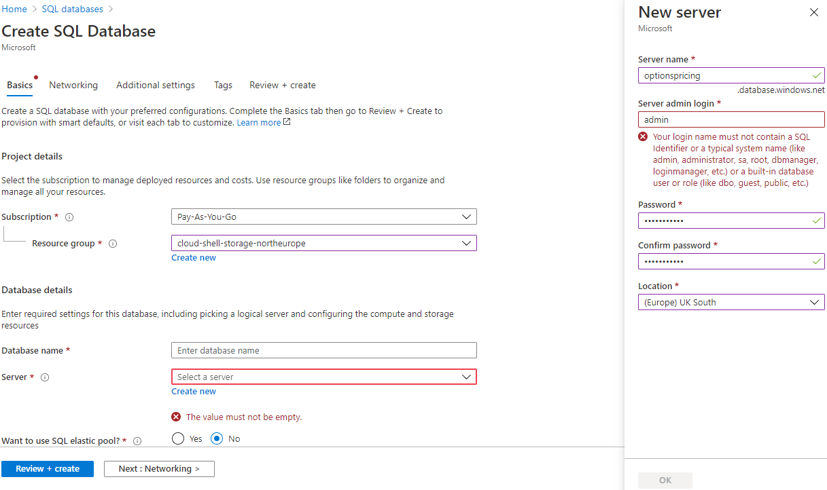

## New database created in this example is Microsoft.SQLDatabase.newDatabaseNewServer_d45e8b3bdf394d6689d83.

## To deploy local SQL Database to Azure, Open SQL Server Management studio.

## 

## Connect to Azure Database

## 

Open New Query and execute table creation script named \StockTicker\StockTicker\StockTicker.Service\DB Creation Scripts

Add new connection string to Web Api StockTicker

Retrieve connections string from SQL click ‘Show database connection String’

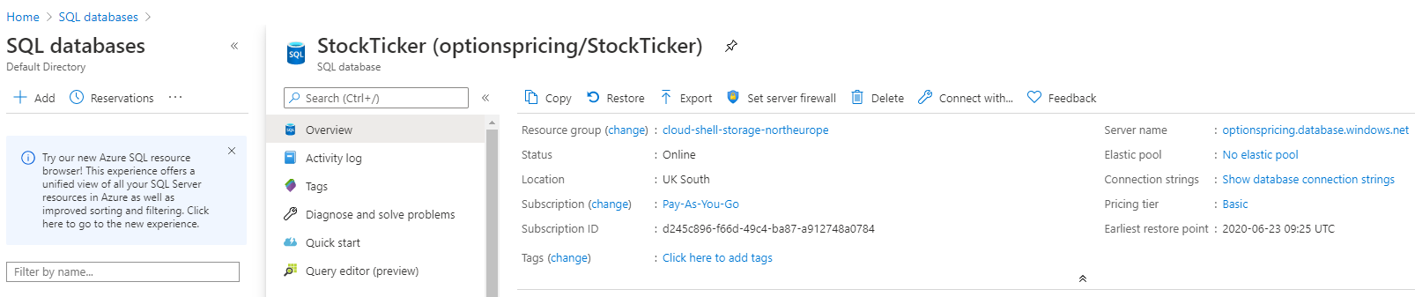

Server=tcp:optionspricing.database.windows.net,1433;Initial Catalog=StockTicker;Persist Security Info=False;User ID=dbadmin;Password={your_password};MultipleActiveResultSets=False;Encrypt=True;TrustServerCertificate=False;Connection Timeout=30;

Edit File appsettings.json in project StockTicket.Web in visual studio community

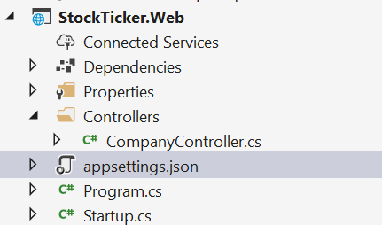

Start Project and ensure data is in database using web call <https://localhost:44325/api/company/GetAllCompanies> in browser

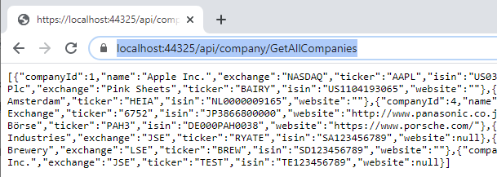**Open and execure Angular web Front end**

Using visual studio code open angular project ‘StockTickerUIClient’.

Edit proxy.conf.json. Insert port that is used by Web API project.

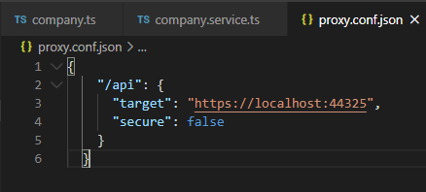

Launch Angular UI by issuing below command in the Terminal Window.

ng serve --port 4203 --proxy-config proxy.conf.json

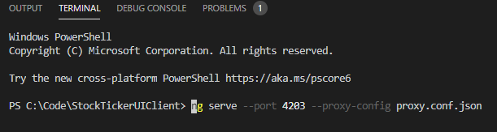

Navigate to website shown in Terminal window, http://localhost:4203/



